**2022's Best Gpus: New And Used Graphics Cards**

It's been two years since we published a guide to the finest GPUs available, and that's because the market has been in shambles for the past two years. During that time, we advised people to hold out if they could, and we also spent a lot of time looking into second-hand options, which, admittedly, didn't hold much appeal.

Things look to be improving, if slowly, and while we still have a long way to go, we understand that many of you are tired of waiting and want to buy something, so what should you get? Let's get started with the lowest price range and work our way up…

**Buy a New Radeon RX 6500 XT or a Used Radeon RX 6500 XT**

The unfortunate Radeon RX 6500 XT is the cheapest new graphics card for people trying to spend as little as possible. In short, it's a subpar device with a slew of flaws that costs much too much for what it is. However, there isn't a better option for under $450, so if you're in desperate need of a new graphics card and the used market isn't an option, this is it.

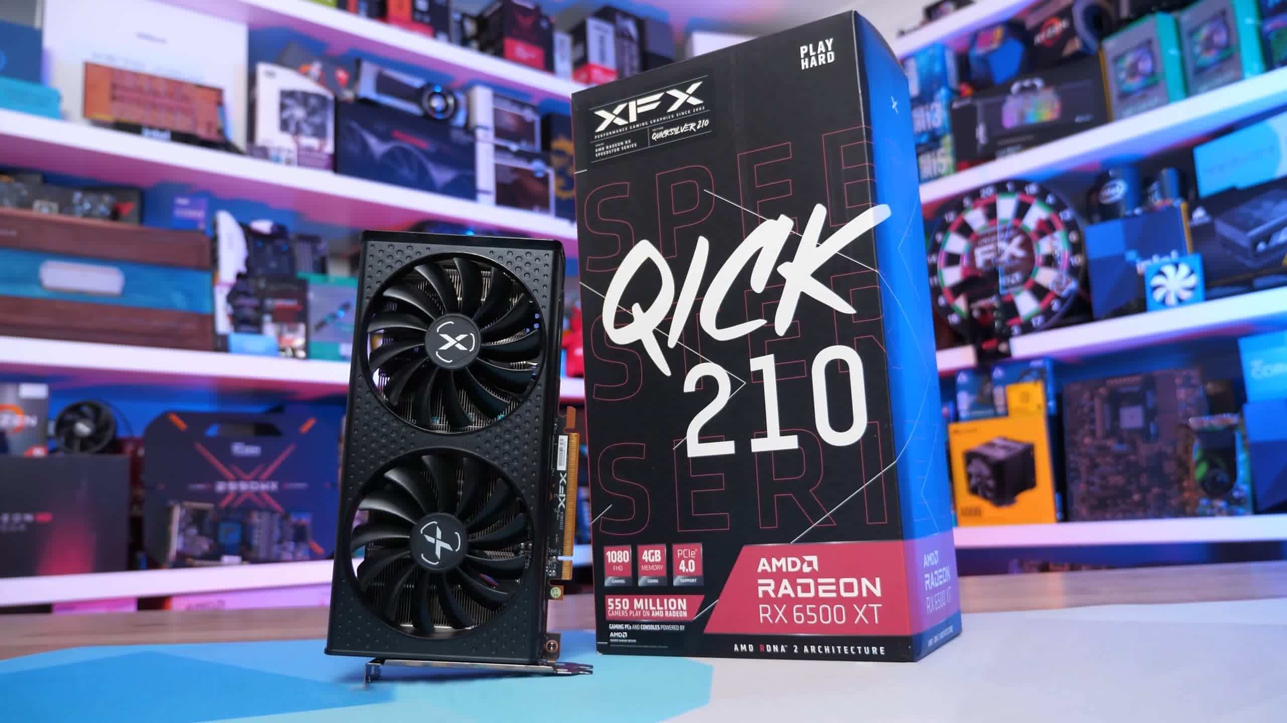

In all honesty, we'd rather wait or do something else with our time than spend $270 on a graphics card that can't even reach 60 frames per second in modern games like Cyberpunk 2077 or Dying Light 2 when set to the lowest quality settings at 1080p. This one will be like milk as it ages.

If you have access to a heavily used market, we recommend the Radeon RX 570 4GB, which is frequently available for less than $200 and is arguably a better product. A used Radeon 5500 XT 4GB or GTX 1650 Super are superior items for similar money, or roughly $270, so look for those if you can locate them.

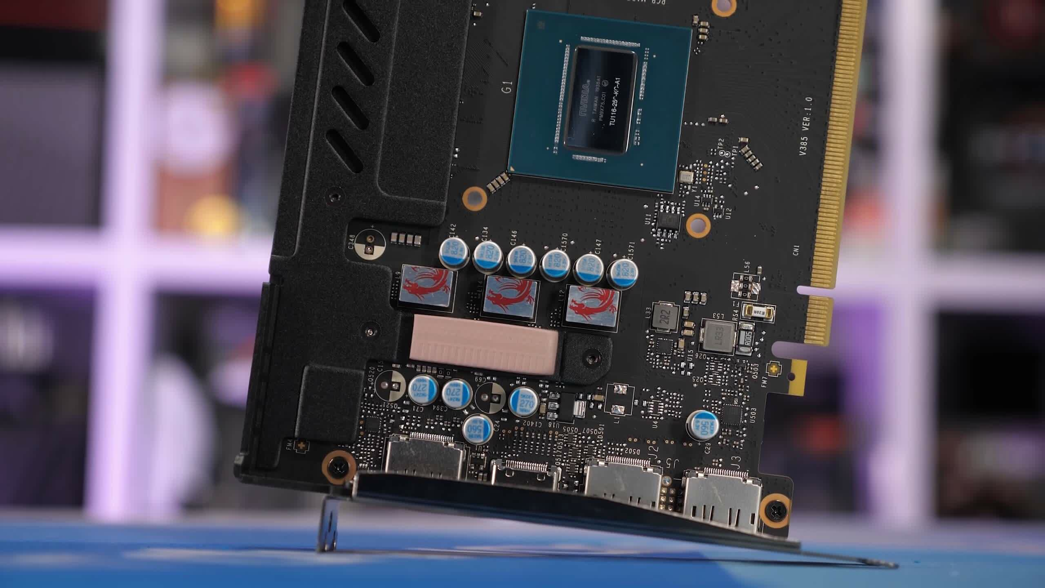

However, if you can get an RX 6500 XT for less than $200 MSRP, that's probably the way to go. However, keep in mind that if it does reach that price in a few months, other GPUs will almost certainly have reduced in price as well, so make sure you evaluate all of your options before buying.

The Best Starting Point ($500+)

**AMD Radeon RX 6600 Graphics Card**

As we have just shown, you don't get much for $270 when you buy the 6500XT. What is the best way to get today's games at respectable settings while still having enough headroom for the future?

The AMD Radeon RX 6600 is the best option. Some models are priced at $450 while others cost over $500. RX 6600 cards are available in Australia for $650 AUD. This is approximately the price of an RTX3050. The cheapest RTX3050 in the US is currently available at Newegg for $600. This listing comes from third-party sellers. The RTX 3060 is priced higher than the RX 6600, and it is expected to be comparable in performance. It costs upwards $750.

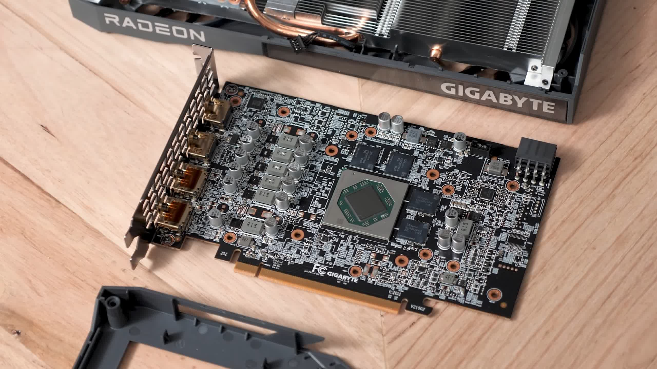

In other words, there isn't a better option for a new or used RX 6600 right now, so it's a no-brainer. While we weren't crazy about the RX 6600 when it first came out, it's turned out to be a fantastic price with good availability in the current market. It's also miles ahead of the 6500 XT in terms of display outputs, PCIe bandwidth, VRAM capacity, hardware encoding, and AV1 decoding; in short, it's a true graphics card.

It also outperforms the RTX 3050 in normal rasterization, thus it's not worth buying unless the GeForce GPU is at least 20% cheaper than the RX 6600.

The Best You Can Get for $1,000 or Less

**AMD Radeon RX 6700 XT graphics card**

What's the greatest option if you're dead set on getting a graphics card right now and need more performance but don't want to spend more than $1,000? That, in our opinion, is the Radeon RX 6700 XT. It was a good product at its original MSRP, giving the RTX 3070 a run for its money.

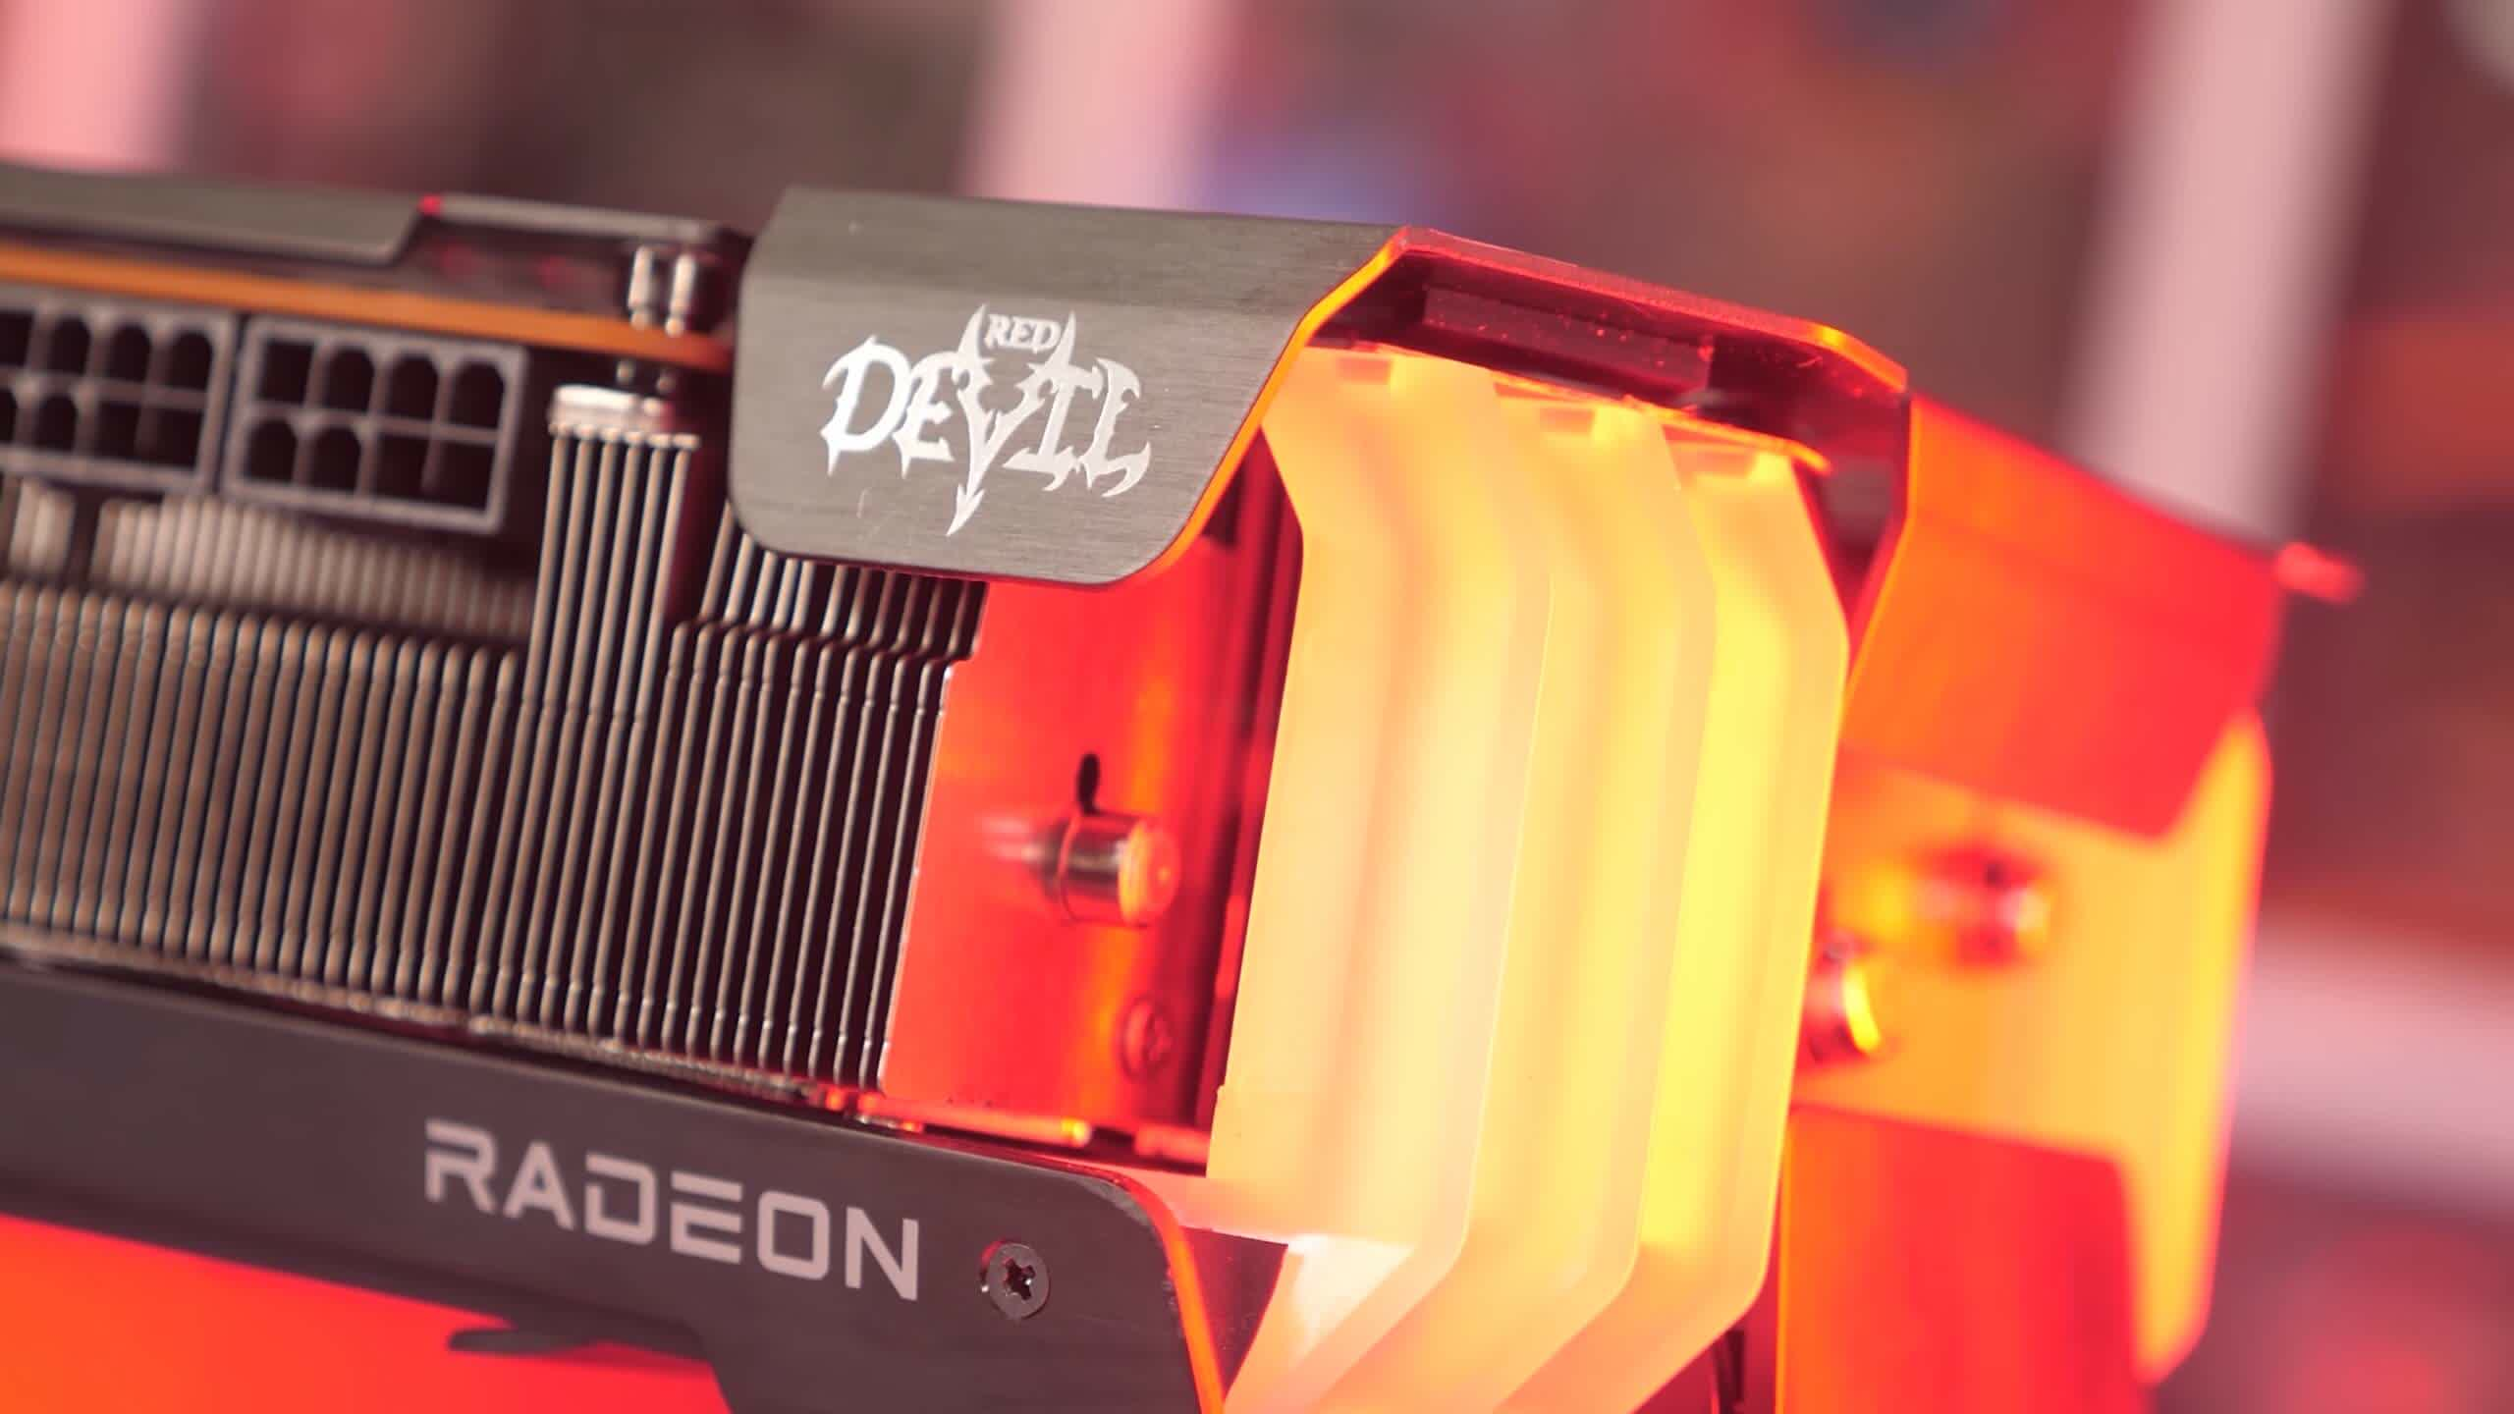

The Radeon 6700 XT outperforms the RX 6600 by 40%, enables full PCIe x16 bandwidth, boosts VRAM capacity to 12GB, and costs roughly $900 today. You're practically paying a 100% price premium for 40% better performance, which is why we recommend the RX 6600 instead if you have the option.

You'll pay substantially more for roughly this level of performance from Nvidia, since the RTX 3070 starts at $1,100, with the newer 3070 Ti starting at around $1,200. The 6700 XT is a better deal at $900 unless you're buying particularly to play games with ray tracing/DLSS enabled.

Best High-End GPU for the Money ($1,500)

**AMD Radeon RX 6900 XT Graphics Card**

Given how insane the market is — and has been for the past two years — graphics cards that once seemed ridiculous may no longer seem that absurd... depending on how you look at it. Take, for example, the Radeon RX 6900 XT. We thought this product, like the GeForce RTX 3090, made little sense when it was first released. The MSRP was over 50% more than the 6800 XT, despite single-digit performance gains of roughly 8% on average.

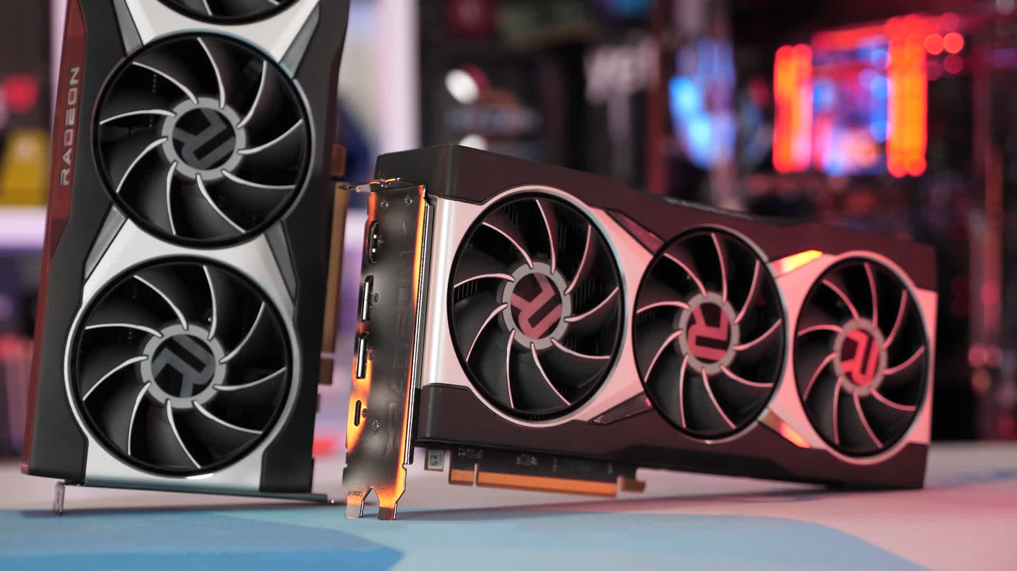

With the 6900 XT, you get nothing additional than a minor performance improvement. It was effectively the same product... for a lot more money. The memory capacity and bandwidth were the same, so other than a few extra cores that permitted the 8% increase, it was essentially the same product... for a lot more money. However, the Radeon 6900 XT costs only 10% more than the 6800 XT in today's market, so if you're ready to spend $1,500, you might as well get the flagship model.

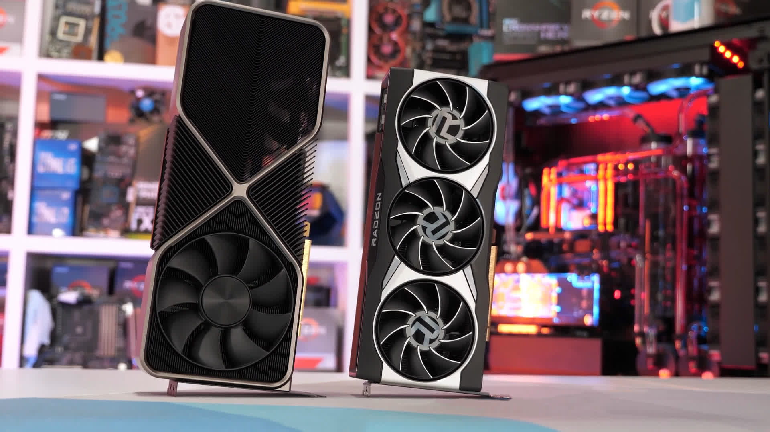

Nvidia GPUs are much more expensive, making them unaffordable for most gamers. The RTX 3080's base model costs $1,600, which isn't justified given that it's often slower than the 6900 XT. The current 12GB version of the 3080 costs $1,650, while most models cost more than $1,800, and the 3080 Ti costs an outrageous $2,000.

The very best of the best (money is no object)

**GeForce RTX 3090 from Nvidia**

The GeForce RTX 3090 is still the quickest GPU money can buy, but for $3000, it's ridiculous. We recognise that some people would pay top dollar for these ultra-high-end items, but who makes the finest gaming GPU? The 6900 XT and the RTX 3090 are going head to head.

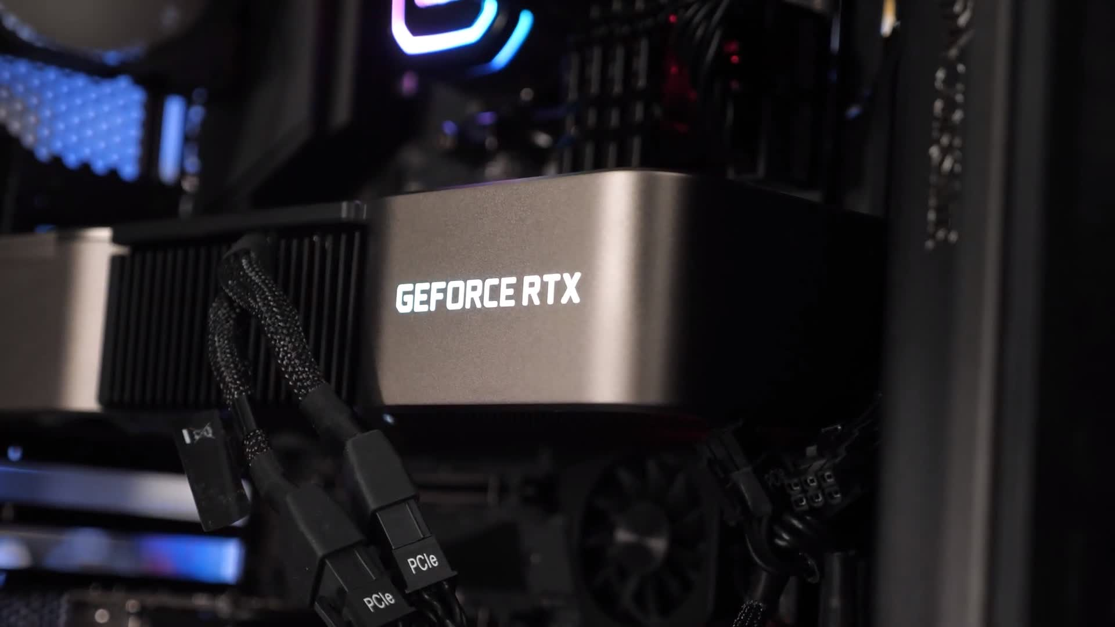

The RTX 3090 is a far superior product from a technical standpoint. It supports DLSS, which is useful for improving speed at high resolutions, but it also provides far better ray tracing performance. The GeForce is normally the speedier product when it comes to rasterization performance at 4K, and with 24GB of GDDR6X memory, it's highly enticing to those who care about bragging rights.

The RTX 3090's main flaw is, of course, its price. Originally expected to cost $500 more than the 6900 XT (a substantial 50% premium), the normal asking price is now closer to $3,100, making it 94 percent more expensive than the 6900 XT, implying that you could buy two 6900 XT for the price of one 3090.

**Wrap Up**

Bottom line, given how costly GeForce cards are right now, you're better off looking at a Radeon GPU if you need to buy a graphics card right now. The RTX 3050 is now Nvidia's cheapest current-gen device, and it costs an outrageous $600, which is a joke for that level of performance. For the same money, you can get the significantly faster 6600 XT, which is approximately 50-60% quicker.

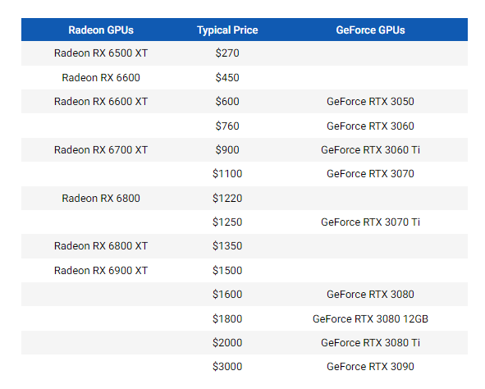

Although the RTX 3060 is slightly slower than the 6600 XT but costs 27% more, the 3060i Ti has a price that matches the 6700 XT and is $900. Although the 6700 XT is slightly slower, this is one of Nvidia's best matchups.

The RTX 3070 jumps to $1100, which is 22% more than the 6700XT and offers just 5% more performance. The price of the 3070 Ti is $1,250. This is higher than the RX 6800, which is slightly slower overall. Nvidia is a good choice for the mid-range segment, which includes the 3060 Ti and the 3070 Ti. Nvidia is still worse than the low-end, where they have little to no value, and the high-end, where prices get out of control.

The RTX 3080 costs $1,600, which is more than the 6900 XT. This is a bad deal considering the Radeon gives roughly 15% more performance at 4K. For the 12GB 3080, things only grow worse, and for the 3080 Ti, they get even worse. That is where we are at the moment. Although pricing remains poor, availability of some models appears to be increasing, so maybe things will continue to improve.